Siddiq and Friends
ST10438345

INSY 6212
Assignment 2

Table of Contents
Question 1) 2
1.1) 2
1.2) 3
1.3) 4
Question 2 5
Question 3 7
3.1 7
3.2 11
Question 4 12
4.1 12
Question 5 14
5.1 14
5.2) 16
Self-evaluation report 16
References 18

Question 1)

1.1)
  - The importance of project evaluation and an explanation on why you would need to have one set up for your project:
Importance of Project Evaluation:
Project evaluation is significant since it aids in measuring how good a project reaches it and objectives. It permits you to evaluate performance, recognising strengths as well as weaknesses, guaranteeing resources are utilised effectively, and being a factor whether the project conveys worth to the community (Dr Shehla Khalid, 2023). Evaluation also issues teaching for enhancements that may occur in the future and guarantee accountability for cost, time and lastly quality (Landau, 2025).
Why you need it for your project:
You need it because having a project evaluation construct aids in keeping a record of your progress, acknowledging problems in an early stage, and make decisions that are well informed to keep the project on track (Dr Shehla Khalid, 2023). It guarantees that your project reaches its planned outcomes, remains within schedule as well as budget, and issues feedback that are at a good use for enhancing future projects (Landau, 2025)
Here are some reasons for its necessity:
- Helps identify community needs, such as the frequency and nature of unreported incidents.
- Confirms feasibility within the allocated budget of R1 750 000 and the 12-month timeframe.
- Strengthens stakeholder confidence by presenting a compelling case for the incident reporting solution.

1.2)
  - The cross-platform development trend that has been selected and a discussion on it:
What a Cross-Platform Development is:
Cross-platform development involves in making a single application that operates seamlessly across various operating systems, such as iOS and Android, using a shared codebase (Awati, 2023). This approach gets rid of the need to develop and manage separate applications by leveraging frameworks like Flutter, React Native, or Xamarin (Stojchevska, 2025).
How Cross-Platform Development helps meet my project deadlines:
- Code reuse enables developers to write most of the code once and deploy it across various platforms, saving a lot of time (Warp, 2024).
- Common functionalities across platforms lessen the duplication in testing and quality assurance efforts (Warp, 2024).
- Simplified debugging and iteration speed up the delivery of monthly milestones within the 12-month timeline (David, 2025).
Potential Risks of Cross-Platform Development:
- Performance limitations: The app may not be as optimized as a fully native application on a specific platform (Coglianese, 2017).
- Restricted access to native APIs: Integrating device-specific features, such as GPS or camera functionality, may be more challenging (Curity, 2024).
- UI/UX inconsistencies: Achieving a native look and feel across different platforms can be difficult, potentially leading to user frustration (Niebla, 2023).
How Cross-Platform Development can enhance usability and user experience:
- Guarantees consistent functionality for iOS and Android users, fostering trust when reporting sensitive incidents (Cherkashyn, 2017).
- Enables swift update rollouts, enhancing app security and usability based on user feedback (Birmacher, 2024).
- Reduces development costs and time, allowing resources to be allocated toward usability testing and UI improvements (Longe, 2024).
- Supports usability in areas with poor network coverage by offering offline access and local caching (Pothineni, 2025).

1.3)
  - Five major identified deliverables that would form part of my project charter:
1 - Conditions Document
Defines the functional and non-functional requirements for the anonymous incident reporting app, guaranteeing clarity on system capabilities and constraints (Komnenic, 2025).
2 - UI/UX Design Prototypes
Includes mock-ups and wireframes illustrating how the application will look and function over distinctive platforms, guaranteeing an intuitive user experience (Deshpande, 2023).
3 - Minimum Viable Product (MVP)
A working prototype showcasing core functionalities such as GPS tagging, anonymous reporting, and basic offline access to demonstrate essential capabilities (AgileMania, 2025).
4 -Testing and Quality Assurance Reports
Documentation from alpha and beta testing phases, detailing usability evaluations, performance assessments, and bug-fixing efforts to enhance app reliability (Westland, 2024).
5 - User Training and Deployment Plan
A strategy for launching the app on the Play Store and App Store, incorporating user training and community engagement initiatives to improve adoption and effective use (Davis, 2024).

Question 2
  - A graphic chart work breakdown structure (WBS) depicting the decomposition of the project requirements:
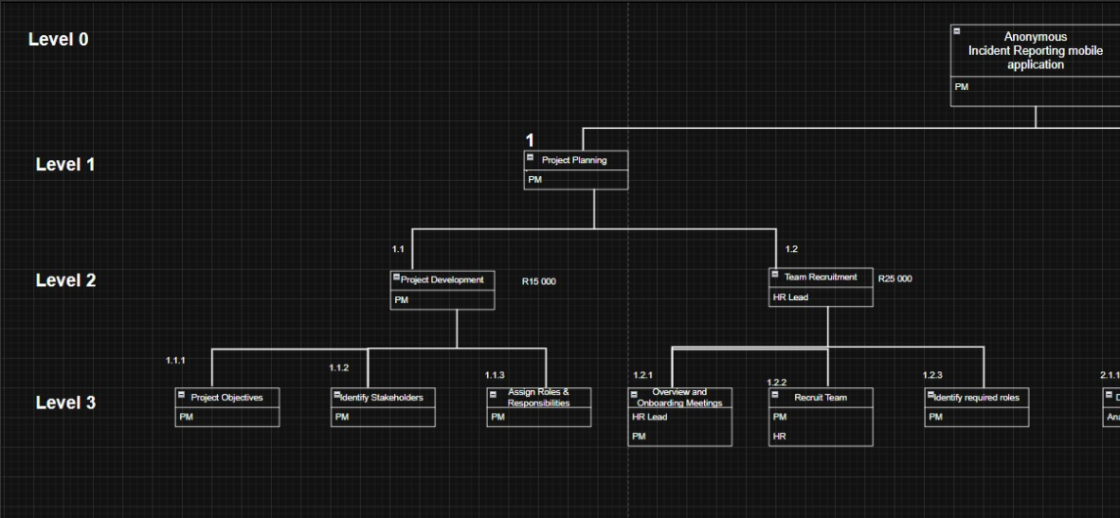
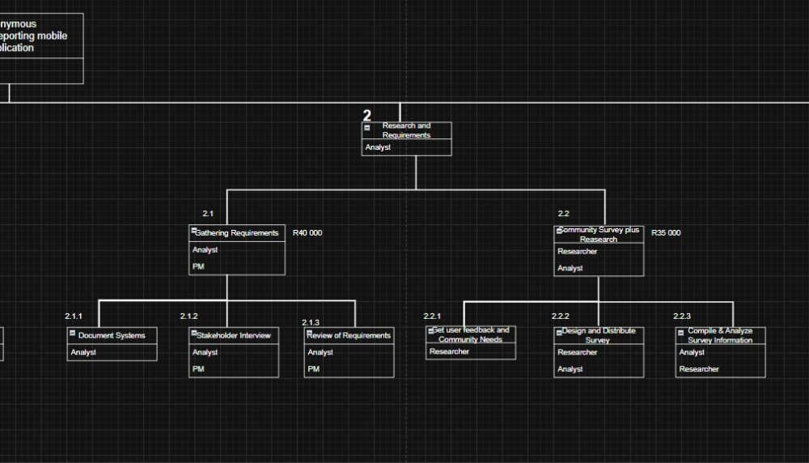
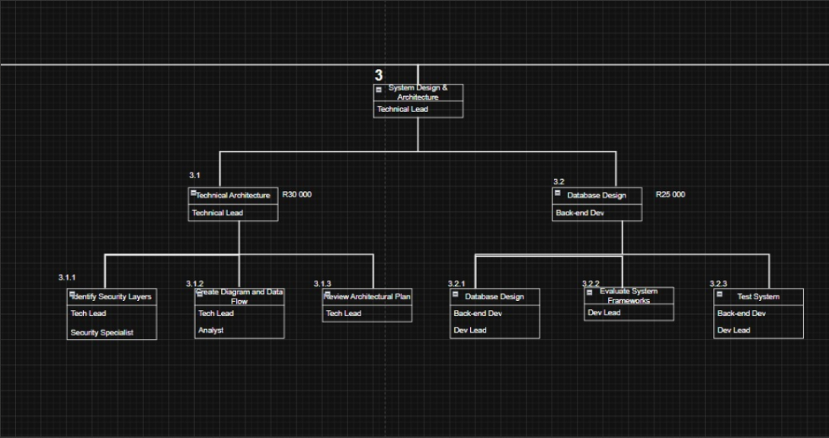
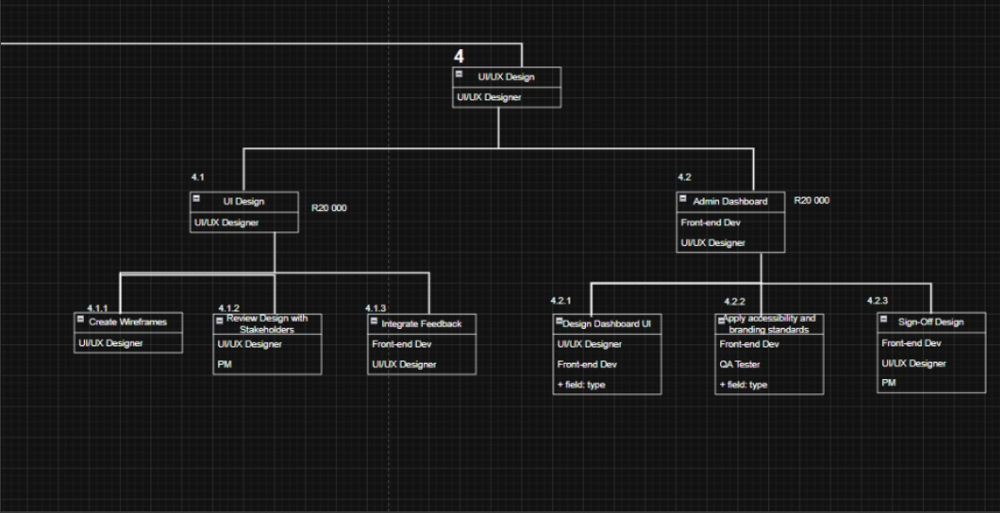
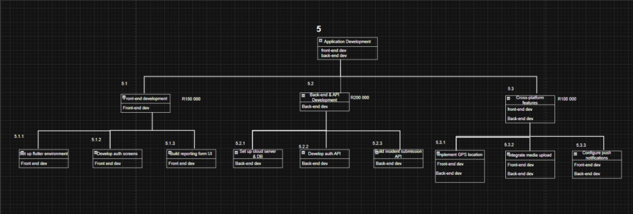
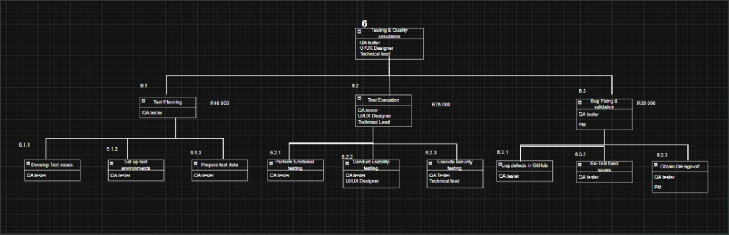
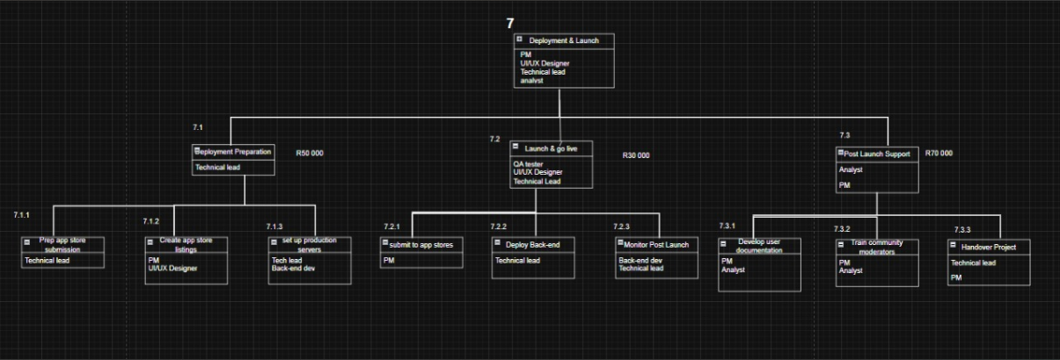

Question 3

3.1
  - Gantt chart and a project timelines table showing a detailed breakdown of the project:
The table presents a comprehensive project timeline for the 12-month development and rollout of the Anonymous Incident Reporting mobile application. It details the breakdown of activities, their durations, dependencies, assigned responsibilities, budget allocations, and major milestones essential for project execution.

ID | Activity Name | Duration (Days) | Predecessor(s) | Resource Assigned | Estimated Cost (ZAR)
1 | Project Charter Development | 5 | - | Project Manager | 15,000
2 | Team Recruitment | 10 | 1 | HR Lead | 25,000
3 | Requirement Gathering | 10 | 2 | Analyst, PM | 40,000
4 | Community Survey and Research | 10 | 3 | Researcher, Analyst | 35,000
5 | Define Technical Architecture | 7 | 3 | Technical Lead | 30,000
6 | Choose Tech Stack (e.g., Flutter) | 3 | 5 | Dev Lead | 10,000
7 | Design UI Mock-ups | 12 | 4,5 | UI/UX Designer | 50,000
8 | Review UI with Stakeholders | 3 | 7 | UI/UX Designer, PM | 5,000
9 | Database Design | 7 | 5 | Backend Dev | 25,000
10 | Implement User Authentication | 10 | 6,9 | Frontend & Backend Devs | 45,000
11 | Develop Anonymous Reporting Module | 10 | 10 | Frontend & Backend Devs | 50,000
12 | Develop Location Tracking Feature (GPS) | 7 | 10 | Mobile Developer | 35,000
13 | Develop Offline Access Functionality | 8 | 11,12 | Mobile Developer | 40,000
14 | Implement Incident History Log | 5 | 11 | Frontend Developer | 20,000
15 | Backend Integration (APIs) | 12 | 13 | Backend Developer | 60,000
16 | Admin Dashboard UI Design | 6 | 7 | UI/UX Designer | 20,000
17 | Admin Dashboard Development | 10 | 16,15 | Frontend Developer | 45,000
18 | Data Security & Encryption Implementation | 6 | 15 | Security Specialist | 40,000
19 | Accessibility Testing | 3 | 17 | QA Tester | 10,000
20 | Usability Testing | 5 | 17 | QA Tester | 15,000
21 | Functional Testing | 7 | 17 | QA Tester | 20,000
22 | Bug Fixing (Initial QA Round) | 8 | 19,20,21 | Developers | 30,000
23 | Alpha Release to Internal Users | 3 | 22 | QA, PM | 5,000
24 | Collect Alpha Feedback | 5 | 23 | PM, QA | 5,000
25 | Final QA Round and Bug Fixing | 7 | 24 | Developers | 25,000
26 | Play Store and App Store Setup | 5 | 25 | PM, Mobile Dev | 3,000
27 | App Deployment | 2 | 26 | DevOps | 2,000
28 | Community Awareness Campaign Launch | 15 | 27 | Marketing Specialist | 60,000
29 | Community Training Workshops | 10 | 27 | Trainers, NGO Partner | 50,000
30 | Final Stakeholder Review & Handover | 5 | 28,29 | PM, All Departments | 10,000
Gantt chart showing a detailed breakdown of the project:
The Gantt chart created in Microsoft Excel visually showcases the comprehensive project timeline for the telemedicine platform. It details tasks, durations, dependencies, allocated resources, and key milestones, covering the entire process from project initiation to deployment.

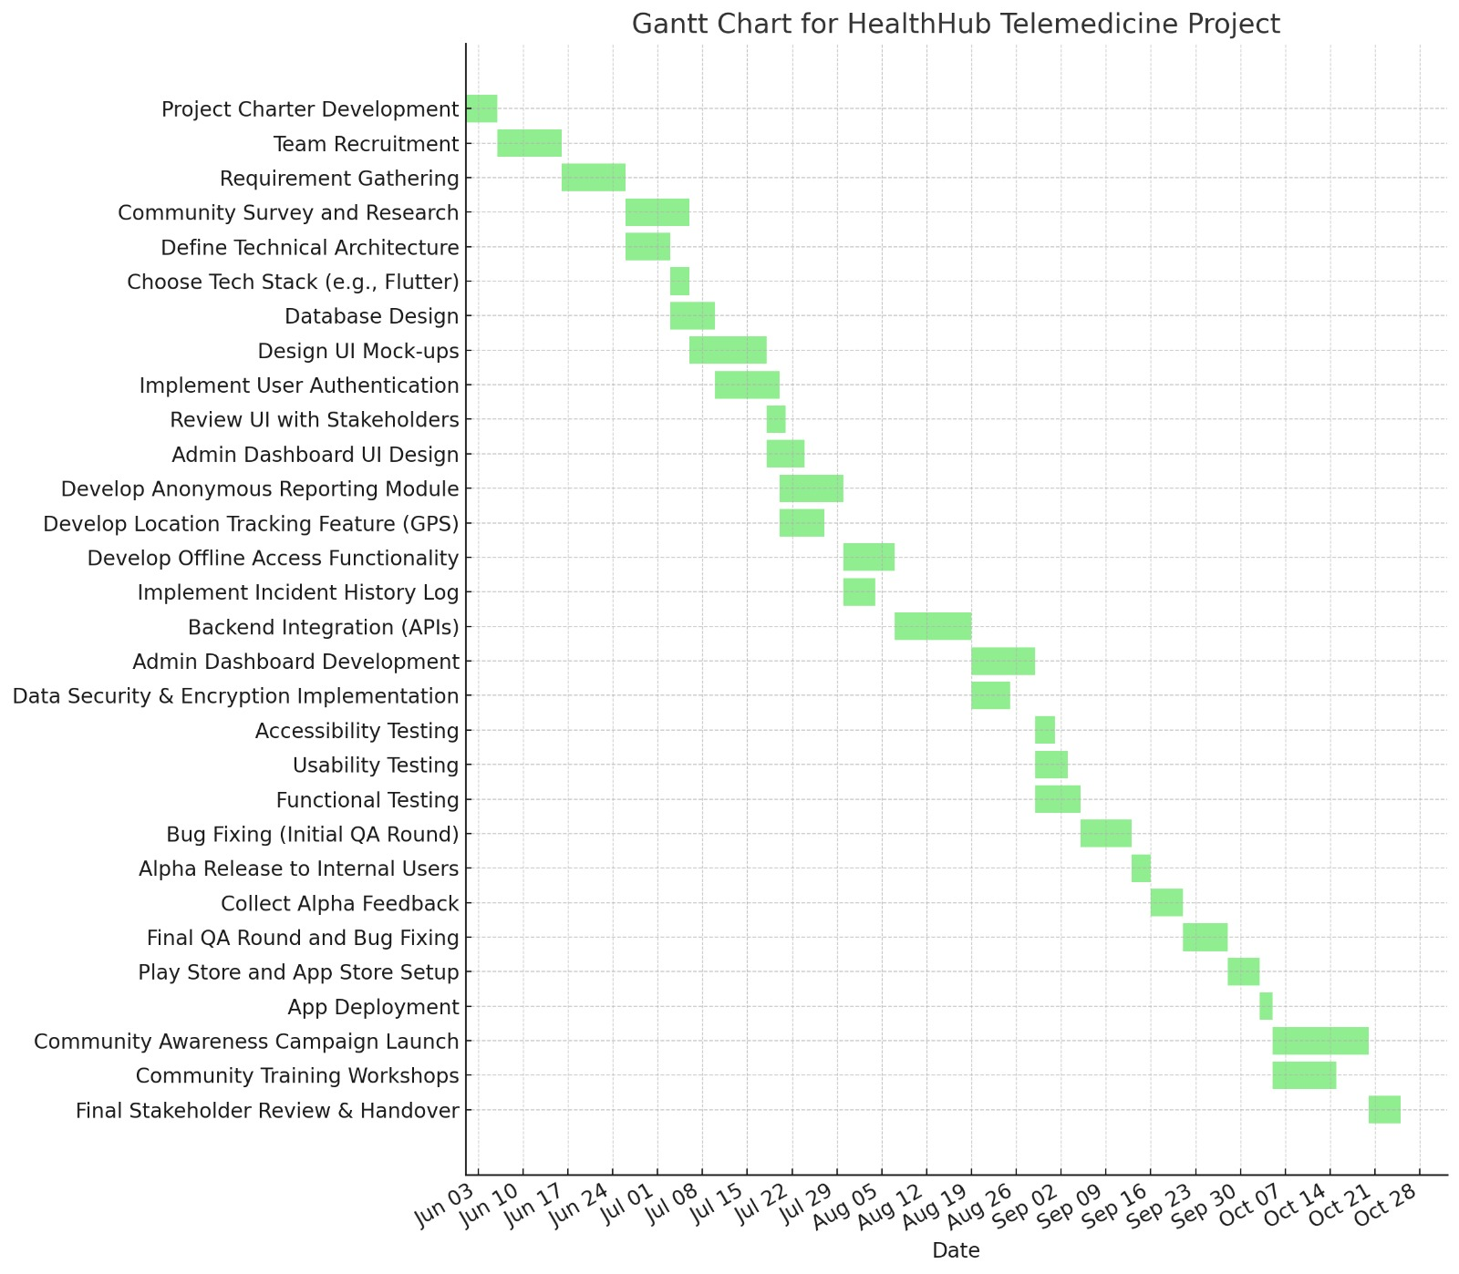
The three milestones in the project timeline:
- Project Charter Completed – This milestone signifies the official start of the project, ensuring alignment on objectives and scope. (End of Week 1)
- App Alpha Release – An internal version of the mobile application will be available for review and feedback, allowing for early insights and refinements. (End of Week 10)
- Go-Live Deployment – The final, fully tested, and secure platform will be launched for public use, marking the culmination of development efforts. (End of Week 14)

3.2
  - An issue Log that matches the identified activities in your work breakdown structure:
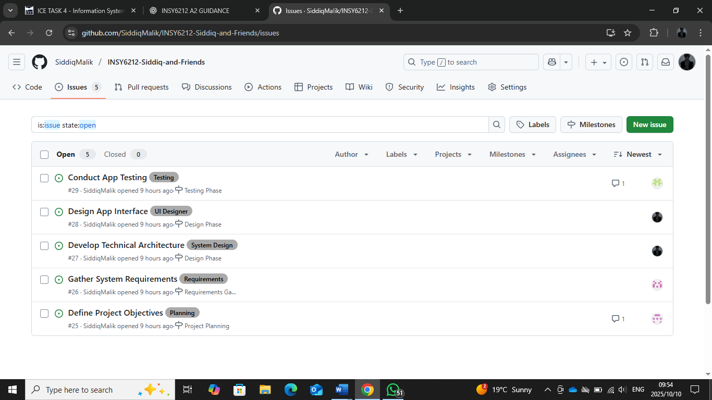

Github repository link:
https://github.com/SiddiqMalik/INSY6212-Siddiq-and-Friends

Question 4

4.1
  - Project Network Diagram (Activity-on-Node):
ID | Activity Name | Duration | Predecessors
A | Project Planning | 5 | -
B | Requirement Gathering | 4 | A
C | UI/UX Design | 6 | B
D | Core App Framework Setup | 5 | B
E | Anonymous Report Module Dev | 10 | C, D
F | Location Tracking Dev | 7 | D
G | Offline Access Implementation | 8 | E, F
H | Backend API Integration | 12 | G
I | Testing (Functional, Usability, QA) | 7 | H
J | Bug Fixes | 8 | I
K | App Store Deployment | 5 | J
L | Community Training and Awareness | 10 | K

ID | Dur | ES | EF | LS | LF | Float | On Critical Path?
A | 5 | 0 | 5 | 0 | 5 | 0 | Yes
B | 4 | 5 | 9 | 5 | 9 | 0 | Yes
C | 6 | 9 | 15 | 9 | 15 | 0 | Yes
D | 5 | 9 | 14 | 10 | 15 | 1 | No
E | 10 | 15 | 25 | 15 | 25 | 0 | Yes
F | 7 | 14 | 21 | 16 | 23 | 2 | No
G | 8 | 25 | 33 | 25 | 33 | 0 | Yes
H | 12 | 33 | 45 | 33 | 45 | 0 | Yes
I | 7 | 45 | 52 | 45 | 52 | 0 | Yes
J | 8 | 52 | 60 | 52 | 60 | 0 | Yes
K | 5 | 60 | 65 | 60 | 65 | 0 | Yes
L | 10 | 65 | 75 | 65 | 75 | 0 | Yes

The tables above and diagram below provide a visual representation of the project timeline, outlining activity durations and dependencies. The early start (ES) and early finish (EF) times were determined through a forward pass, while the late start (LS) and late finish (LF) times were calculated using a backward pass. The critical path highlights the longest chain of interdependent tasks, establishing the minimum possible project duration—75 days in this case.

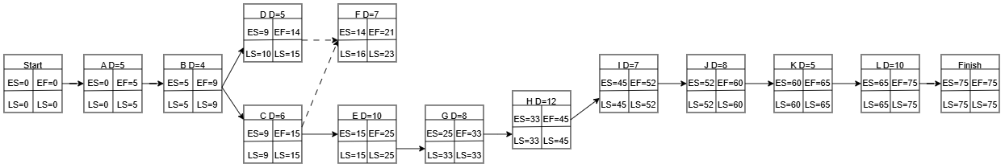
Figure 1 Network Diagram

Critical Path Calculation Notes:
- Forward Pass calculates Earliest Start (ES) and Earliest Finish (EF)
- Backward Pass calculates Latest Start (LS) and Latest Finish (LF)
- Critical Path = Path with 0 Slack
- D = duration (days)
Critical Path Identified:
A → B → C → E → G → H → I → J → K → L

Question 5

5.1
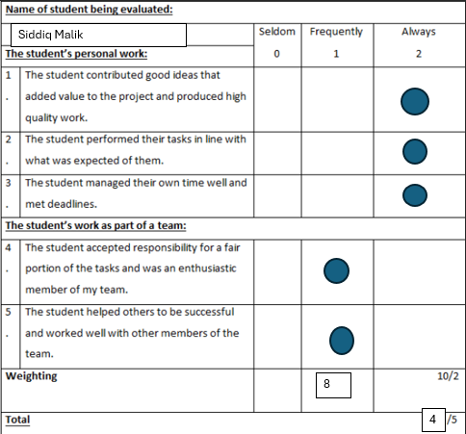
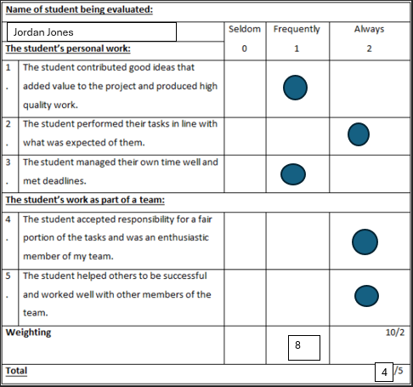

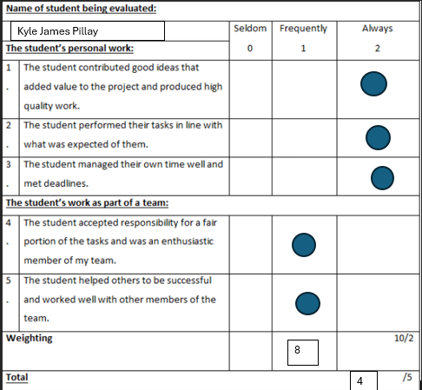

5.2)

Self-evaluation report
The purpose of this project was to engage with project management skills and abilities that we used in the first assignment and answer these questions but in a group setting. The value of the project was learning to apply ourselves and develop the skill of working as a team and being a team member dubbed with responsibility as well.
Practically doing the diagrams and writing out all the required reports helped in giving me firsthand experience of what it’s like to put together a project and to manage one. During the assignment technical skills were developed which are important for project management. Creating visual diagrams such as Work breakdown Structures using software tools and Ghantt Charts. The skill to research really does become important especially when working as a group, with different members coming with different perspectives, but we were able to put together definitions and relevant explanations of the topics in the project which was good. Good management and communication were important in ensuring the success of the project because there are just too many components in this project for there to be no proper communication and/or management.
During feedback sessions that is when we could go through all points and decide on what makes the most sense. I made sure to organise focused group meetings regularly which at each of those meetings each group/team needed to provide updates on their tasks and responsibilities, and they were also required to ask questions and add inputs as other teams presented their updates.
Through group conversations, and internet research, I put together and presented information throughout the project. I gathered and arranged data I though was important using programs like Google Scholar to help us achieve the goals of the project. I created thorough summaries of the findings and added to team reports that were distributed at stakeholder reviews and group meetings. These presentations made it easier to convey our progress and my message and made sure that everyone involved understood the project's requirements. I did well in data analysis, work organisation, and time management during the assignment.
In conclusion this project offered a priceless chance to practise and improve my interpersonal and technical project management abilities in a real-world, team-based setting. I was able to personally witness the value of accountability, collaboration, and communication in accomplishing common objectives by working as a team. Through conducting research, arranging data, and creating tools like Gantt charts and work breakdown structures, I was able to improve my technical skills and make a significant contribution to the group's advancement. Throughout the project, we were able to stay in sync and productive because to the regular teamwork, feedback sessions, and organised meetings. All things considered, this experience helped strengthen my understanding of what good project management is and the need of co-operation, preparation, and flexibility in producing fruitful results.

References
AgileMania, 2025. agilemania.com. [Online]
Available at: https://agilemania.com/what-is-an-minimum-viable-product
[Accessed 8 10 2025].
Awati, R., 2023. www.techtarget.com. [Online]
Available at: https://www.techtarget.com/searchmobilecomputing/definition/cross-platform-mobile-development
[Accessed 8 10 2025].
Birmacher, A., 2024. bitrise.io. [Online]
Available at: https://bitrise.io/blog/post/how-to-minimize-the-negative-impact-of-a-faulty-release-with-a-staged-rollout
[Accessed 8 10 2025].
Cherkashyn, A., 2017. medium.com. [Online]
Available at: https://medium.com/@andycherkashyn/how-to-keep-both-ios-and-android-native-applications-consistent-3a1343ed6a62
[Accessed 8 10 2025].
Coglianese, C., 2017. scholarship.law.upenn.edu. [Online]
Available at: https://scholarship.law.upenn.edu/faculty_scholarship/1858/
[Accessed 8 10 2025].
Curity, 2024. curity.medium.com. [Online]
Available at: https://curity.medium.com/how-to-secure-api-access-in-mobile-apps-a072d764ae46
[Accessed 8 10 2025].
David, A., 2025. codingcops.com. [Online]
Available at: https://codingcops.com/cross-platform-development/
[Accessed 8 10 2025].
Davis, M., 2024. www.serviceaide.com. [Online]
Available at: https://www.serviceaide.com/resources/blog/5-keys-to-developing-an-end-user-training-plan
[Accessed 8 10 2025].
Deshpande, N., 2023. medium.com. [Online]
Available at: https://medium.com/@thenikhildeshpande/prototyping-in-ui-ux-design-5f73ee8fcbf8
[Accessed 8 10 2025].
Dr Shehla Khalid, S. K. E. A., 2023. www.apm.org.uk. [Online]
Available at: https://www.apm.org.uk/blog/evaluation-in-project-management-what-you-need-to-consider/
[Accessed 8 10 2025].
Komnenic, M., 2025. termly.io. [Online]
Available at: https://termly.io/resources/templates/terms-and-conditions-template/
[Accessed 8 10 2025].
Landau, P., 2025. www.projectmanager.com. [Online]
Available at: https://www.projectmanager.com/blog/improving-project-evaluation-process
[Accessed 8 10 2025].
Longe, T., 2024. uxcam.com. [Online]
Available at: https://uxcam.com/blog/low-cost-mobile-app-development/
[Accessed 8 10 2025].
Niebla, H., 2023. careerfoundry.com. [Online]
Available at: https://careerfoundry.com/en/blog/ui-design/common-ui-design-mistakes/
[Accessed 8 10 2025].
Pothineni, S. H., 2025. www.researchgate.net. [Online]
Available at: https://www.researchgate.net/publication/393910615_Offline-First_Mobile_Architecture_Enhancing_Usability_and_Resilience_in_Mobile_Systems
[Accessed 8 10 2025].
Stojchevska, F., 2025. www.designrush.com. [Online]
Available at: https://www.designrush.com/agency/mobile-app-design-development/cross-platform/trends/cross-platform-app-development
[Accessed 8 10 2025].
Warp, 2024. www.warpdevelopment.com. [Online]
Available at: https://www.warpdevelopment.com/cross-platform-app-development-advantages-and-disadvantages/
[Accessed 8 10 2025].
Westland, J., 2024. www.projectmanager.com. [Online]
Available at: https://www.projectmanager.com/blog/quality-assurance-and-testing
[Accessed 8 10 2025].

